**09/09/2021 OOAD LAB 2 2019103573**

**EXCERSISE 2**

**USE CASE DIAGRAMS FOR CASE STUDIES**

**PROGRAM 1:**

**UML USE CASE DIAGRAM FOR COURSE REGISTRATION**

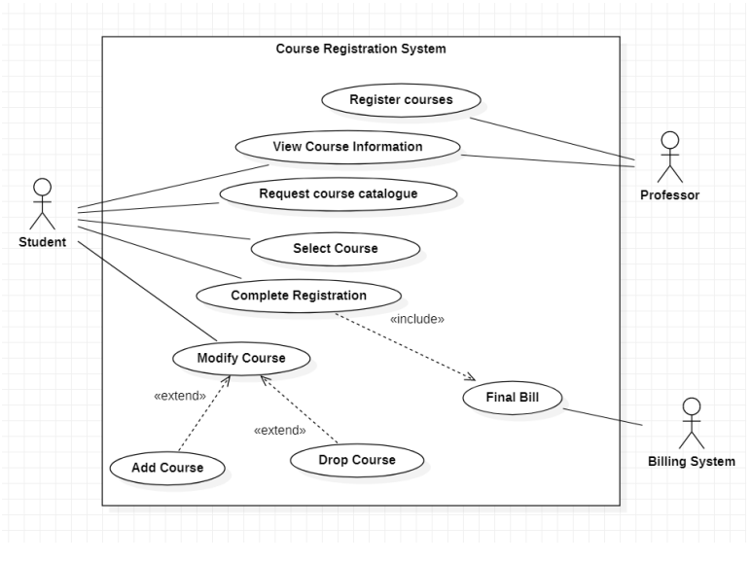

**CASE STUDY 2:**

**UML USE CASE DIAGRAM FOR ONLINE SHOPPING**

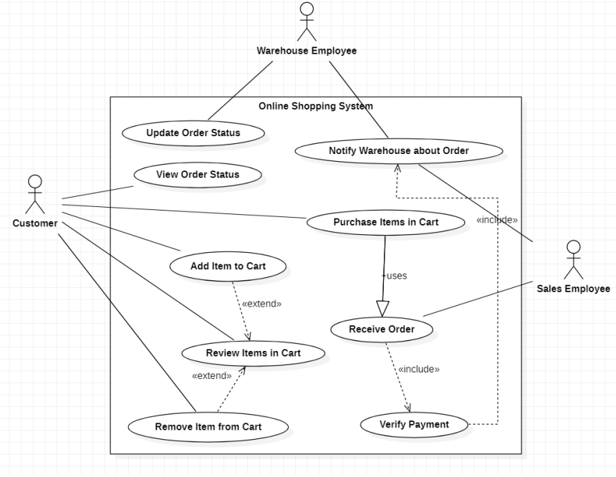

**CASE STUDY 3 :**

**UML USE CASE DIAGRAM FOR CANDY STORE**

